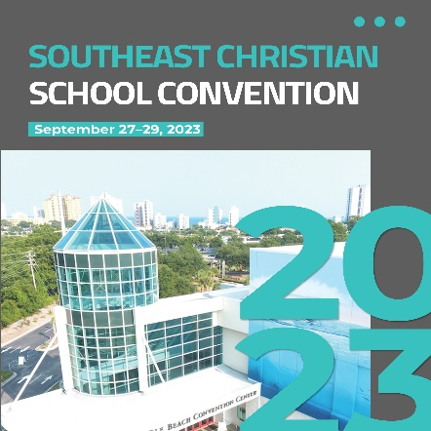**2023 Southeast Christian  
School Convention**

*September 27–29, 2023*

***School/Attendee Registration Letter***

**The 2023 Southeast Christian School Convention is September 27–29, 2023**,at the Myrtle Beach Convention Center.

We are excited to present a great lineup of workshop presenters and general session speakers for this year’s convention. The general session speakers will be Cary Schmidt (author, speaker, and Pastor of Emmanuel Baptist Church), and Steve Pettit (Founder and President of Steve Pettit Ministries).

**Workshops:** Over 105 workshops from presenters across the U.S. have been scheduled to cover a wide variety of topics and services. This year’s convention will utilize eight tracks to allow attendees to participate in specialized sessions: Preschool, Childcare, and Lower Elementary (PR-2); Upper Elementary (Grades 3–5); Middle School (Grades 6–8); Secondary (Grades 9–12); Administrators, Pastors, General, and Special Interest. **After registering, attendees can log in to the Whova Convention App to view the agenda, list of speakers, virtual exhibit area, discussion boards, and other areas.** **Attendees can view the material on the Whova app before, during, and after the convention.**

**Important Convention Registration Details:**

* The 2023 Southeast Christian School Convention registration fees are $85 per attendee if registered by September 8. The registration fees increase to $95 per attendee after September 8. A $20 late fee will be added for attendees registered after September 20. Name tags are not guaranteed for attendees registering after September 20.
* Note: A $10 convention registration rebate will be available by request after the convention for each attendee staying at the Sheraton HQ Hotel.
* If an attendee registration refund is requested, refunds will be given utilizing the criteria below:
  + Refunds requested by September 1 – 75%
  + Refunds requested after September 1 – 50%
  + No refunds given after September 15.
* The convention hotel list is available [here](https://nccsa.box.com/s/spjab3a9orgzqhcwf8bogznrnl05djnl).
* Like the last few years, we will be using the Whova Convention App. Since the convention is onsite, there will be no workshop recordings. To view benefits of utilizing the Whova platform, please [click here](https://whova.com/whova-event-app/).
* All K–12 faculty/staff should register under the Faculty/Staff Attendee Registration. All leadership positions (head of school, administrator, principal, pastor, etc.) should register under the School Leadership Attendee Registration.
* During the last several conventions, many schools registered for their faculty/staff which caused major issues with incorrect email addresses, typos, etc. Hours were spent on the phone/emailing schools trying to correct these issues. The entire process from registering, downloading the app, and logging in to the Whova platform requires that the email address be entered correctly. **Please make sure each faculty/staff member registers themselves using accurate email addresses and name spellings to avoid fees (see below).**
* **Since each faculty/staff member should register themselves, each person will need to enter their individual information for the buyer information *and* attendee information.** Schools should decide how to reimburse all faculty/staff for the registration fee.
* ***A $25 per-individual fee will be assessed for any information entered incorrectly*** causing an attendee (1) not to receive the registration confirmation or (2) not to be able to log in to Whova. If the individual/school is part of any association partnering with the 2023 Southeast Christian School Convention, that association will be charged the fee, and it will be up to the association to decide if they will collect the fee from the individual/school. If the support case is from an individual/school that is not part of a partnering association, that individual/school will be invoiced.
* **All registered attendees must download the Whova Convention App on their mobile device to successfully participate in this year’s convention.** There will be no program book. The workshop agenda, list of speakers, discussion boards, announcements, etc., will all be listed in the Whova Convention App.

**Please forward this letter to your faculty/staff so they can view the registration instructions before registering.**

[**CLICK HERE**](https://whova.com/portal/registration/scsc_202309/)to register for the 2023 Southeast Christian School Convention (credit card only).After registering, check your junk mail if you do not receive a confirmation email from Whova.